Abstract Template for the 34th International Symposium on Rarefied Gas Dynamics

A. B. Author^{1,a)}, C. D. Author¹, and E. F. Author²

¹ Use Complete Addresses for the First Group of Authors.
² Use Complete Addresses for the Second Group of Authors.

^{a)} Corresponding author: your@emailaddress.xxx

This is the abstract template file for the 34th International Symposium on Rarefied Gas Dynamics. Page size is Letter, page borders are 2 cm wide. Title is in Times New Roman font 20pt size, bold, in cap/lower case, single-spaced, and centered at the head of the page. The authors are in Times New Roman font 14pt size, in cap/lower case, and centered. An empty line in 8pt follows the authors. The affiliation and the addresses are in Times New Roman font 12pt size, italic, in cap/lower case, single-spaced, and centered. Use one 12pt empty line between the corresponding author and the text body. The name of the presenter should be in bold.
The text body is in Times New Roman font 10pt size, in single column format, fully justified, and single-spaced. The bibliographic items are referenced as follows [1–4]. Citations in the text are done by numbers in square brackets [] in the order of appearance. The submission deadline and information on the review process and author notifications are given on the Website. The abstract shall be no more than one page long, and the PDF file shall be uploaded on the Symposium website (https://mechmining.uq.edu.au/rgd34) prior to the abstract deadline.

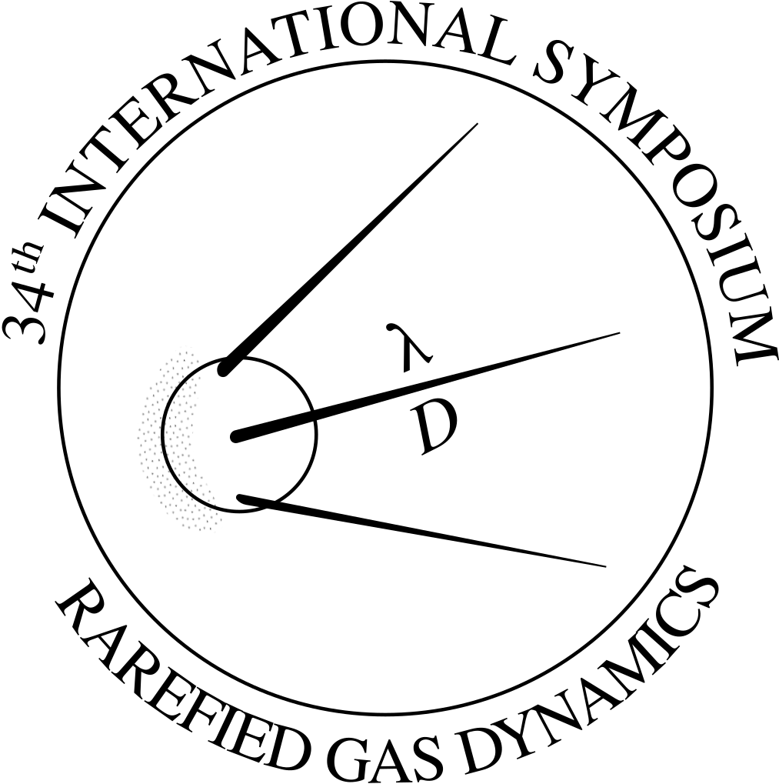
Fig. 1. The figure caption is in Times New Roman 10pt, bold, justified, and single-spaced.

ACKNOWLEDGEMENTS

Details of the funding agency/grant if any, must be in Times New Roman font 10pt size.

REFERENCES

[1] A. B. Author, C. D. Author, Journal Title, 1, pp. 37-42 (2013).
[2] A. B. Author, Book Title (Publisher, City, 2012), pp. 135-142.
[3] A. B. Author, Proc. of the ... Conference... (Publisher, City, 2014), pp. 45-52.
[4] A. B. Author, Thesis Title (Ph.D. thesis, A University 1998).

